Evaluation: ET-OvR
Accuracy: 0.962
Precision: 0.9618974554084252
Recall: 0.962
F1 Score: 0.9619116753859813
Jaccard Index: 0.9272316266571091
Matthews CorrCoef: 0.9525184790377417
Cohen’s Kappa: 0.9525
Specificity: 0.9904999999999999
AUC: 0.997908
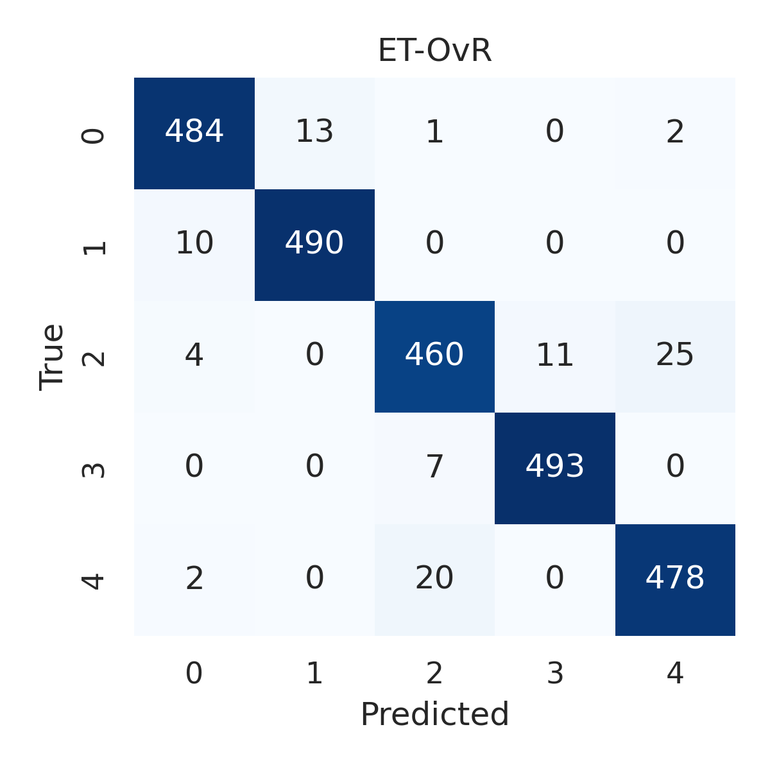

Combined ROC Curves
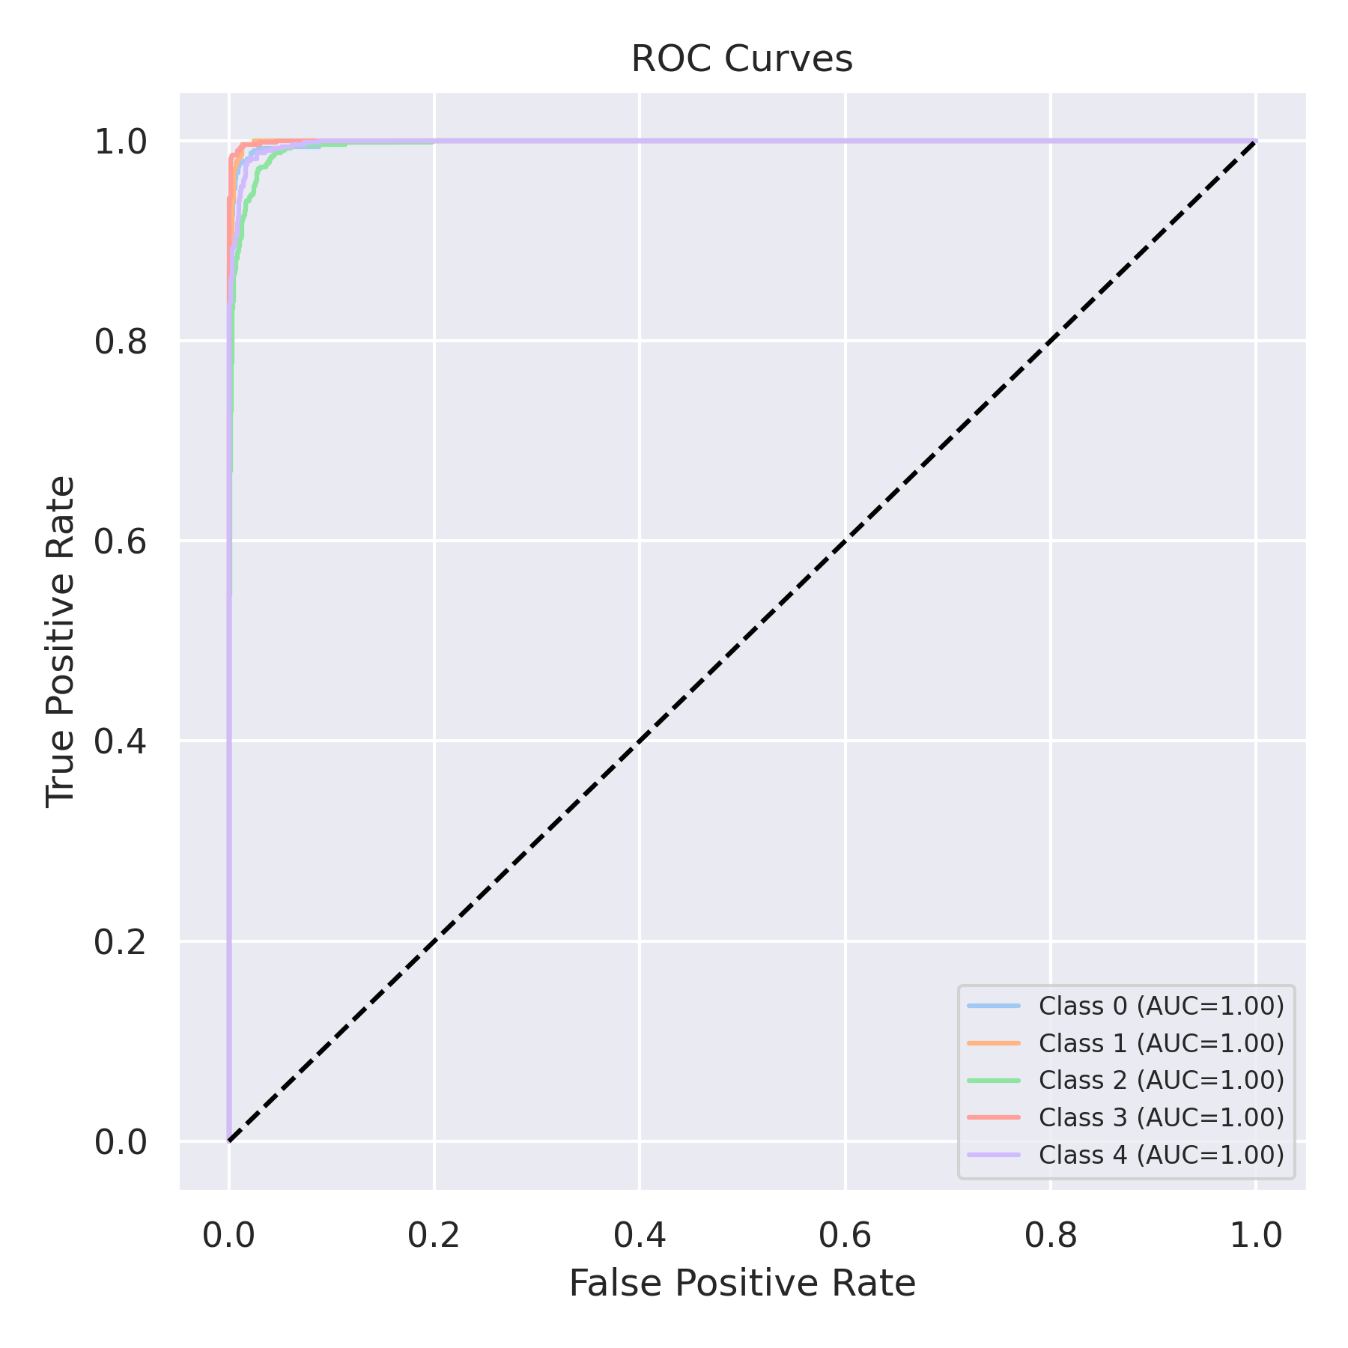

Evaluation: RF-OvR
Accuracy: 0.9556
Precision: 0.9554929097209167
Recall: 0.9556
F1 Score: 0.9554652138369787
Jaccard Index: 0.9155063953047383
Matthews CorrCoef: 0.9445402382712438
Cohen’s Kappa: 0.9445
Specificity: 0.9889000000000001
AUC: 0.9966875000000001
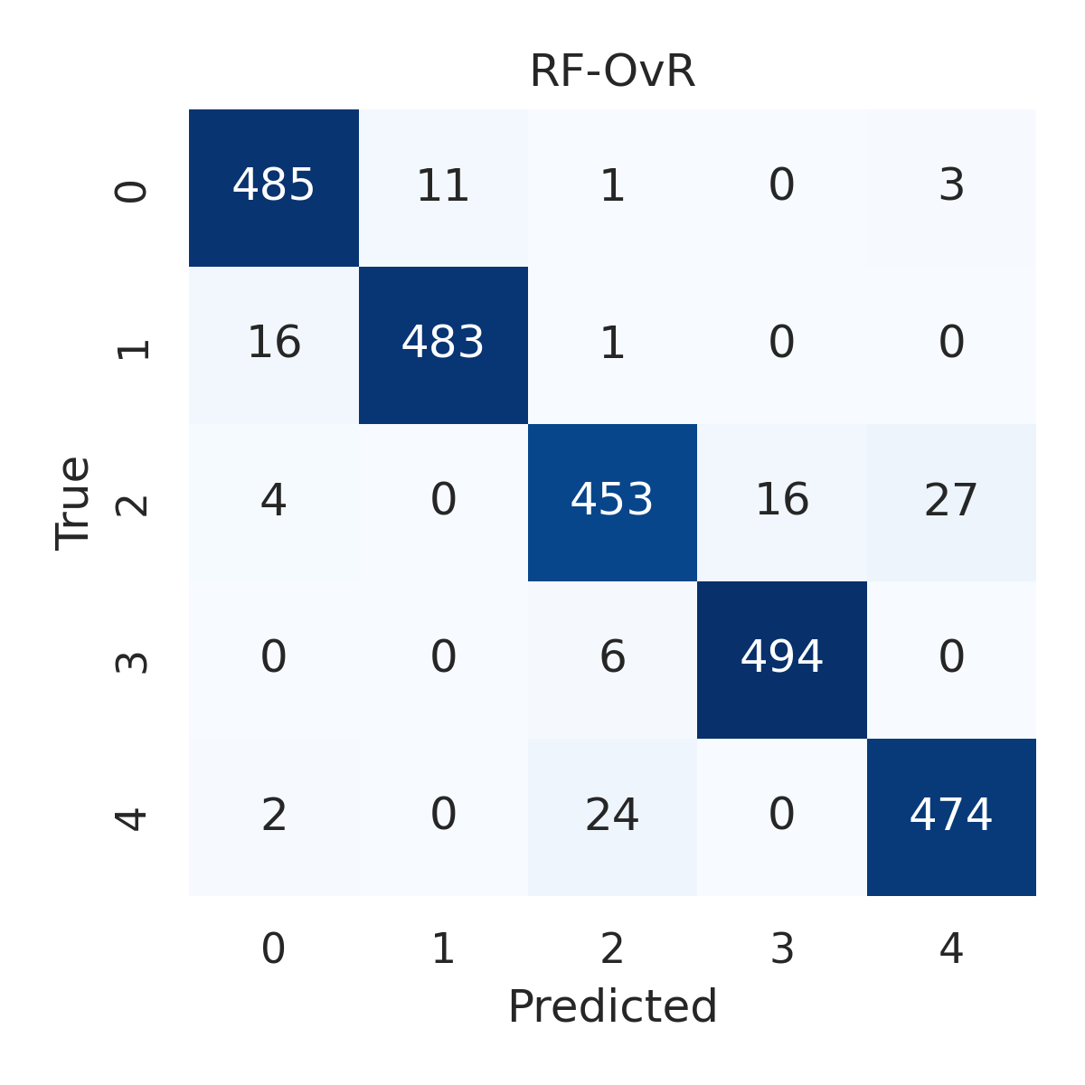

Combined ROC Curves
